EXPRIMENT-4
A SIMPLE APPLICATION FOR CAR BOOKING RESERVATION SYSTEM
Aim:
To create a simple cloud-based Car Booking Reservation System using a cloud service provider to demonstrate the Software as a Service (SaaS) model.
Procedure:
- Log in to the cloud platform (e.g., Zoho Creator).
- Create a new application named Car Booking Reservation System.
- Design a form to store car details such as car model, registration number, type, seating capacity, rental price, and availability.
- Create a customer registration form with details such as name, phone number, email, and address.
- Create a booking form to record booking date, return date, selected car, and customer details.
- Generate reports to display available cars, booked cars, and customer bookings.
- Save and deploy the application on the cloud platform.
- Test the application by entering sample car and booking details and verify that the information is stored and accessed online.
4.1 CUSTOMER INFORMATION
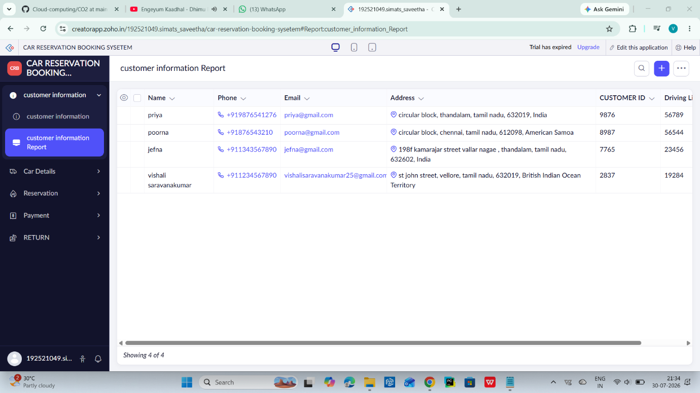

4.2 CAR DETAILS

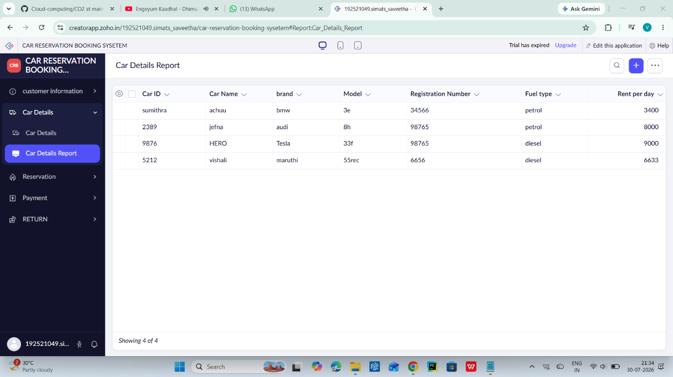

4.3 RESERVATION REPORT

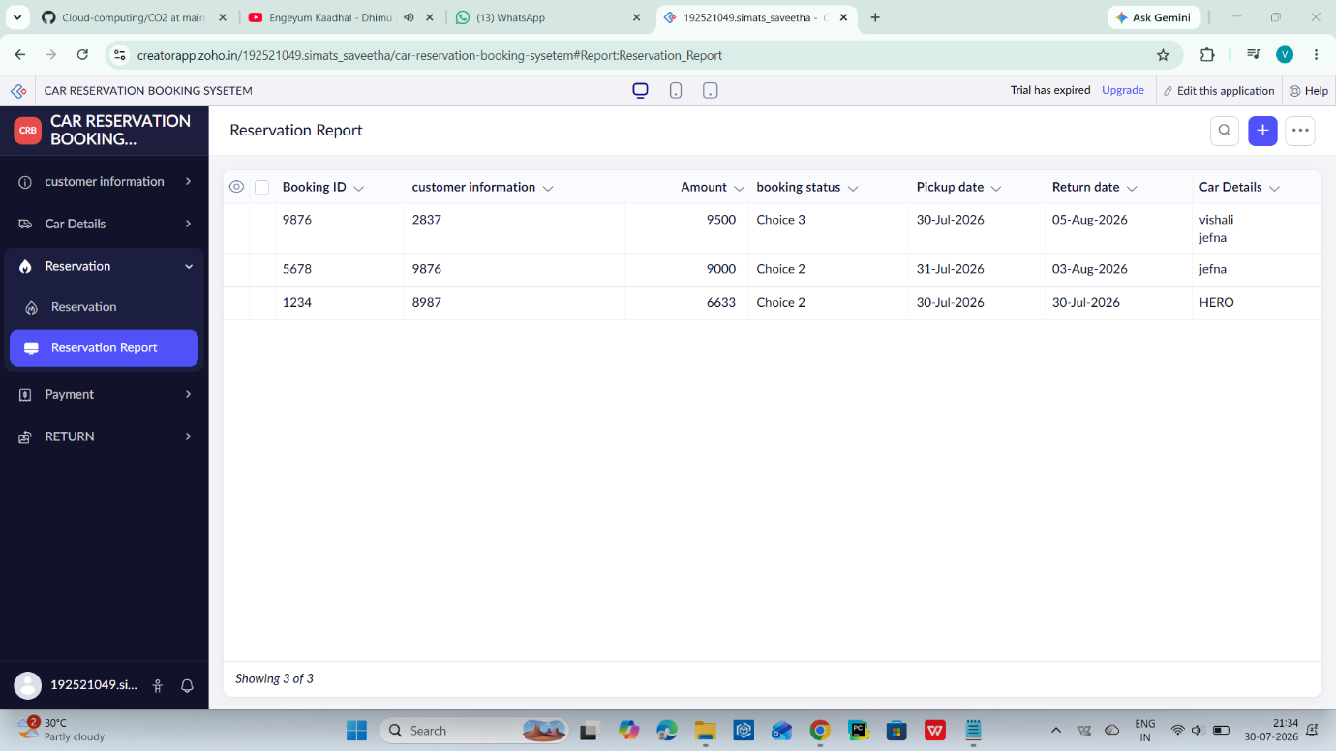

Result:
A cloud-based Car Booking Reservation System was successfully created and deployed. The application enables users to manage car details, customer information, and bookings online, demonstrating the Software as a Service (SaaS) model in cloud computing.

